Scanners
# Convert any printed image of an object into electronic form by shinning light onto the image and sensing the intensity of light’s reflection at any point.

# Color scanners use filters to separate components of color into primary additive colors (red, green, blue) at each point.

# R G B are primary additive colors because they can be combined to create any other color.

# Image scanners translate printed images into electronic format that can be stored into a computer memory.

# Software is then used to manipulate the scanned electronic image.

# Images are enhanced or manipulated by graphics programs like Adobe.

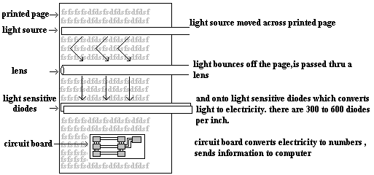

Optical Character Recognition (OCR)
# For text document we use Optical Character Recognition software to translate image into text that is editable.

# When a scanner first creates an image from a page the image is stored in computer’s memory as bitmap.

# A bitmap is a grid of dots, each dot represented by one or more bits.

# OCR software translates the array of dots into text that the computer can interpret as number and letters by looking at each character and trying to match the character with its own assumption about how the image should look like.

